**Group 9 Meeting Notes**

**Date:** 09/02/2023

**Week Number:** 2

**Present:** Arnav Bhattacharya, Haoxian Liu, Kaize Shen, Pallavit Aggarwal

**Agenda:**

Introduction of team members and their roles

Presentation of project objectives and scope

Identification of key research questions

**Minutes:**

The team members introduced themselves and their roles in the project. They discussed the project's objectives and scope and identified key research questions.

**Next Meeting on: 16/02/2023**

**Arnav Bhattacharya, Pallavit Aggarwal, Haoxian Liu, Kaize Shen**

 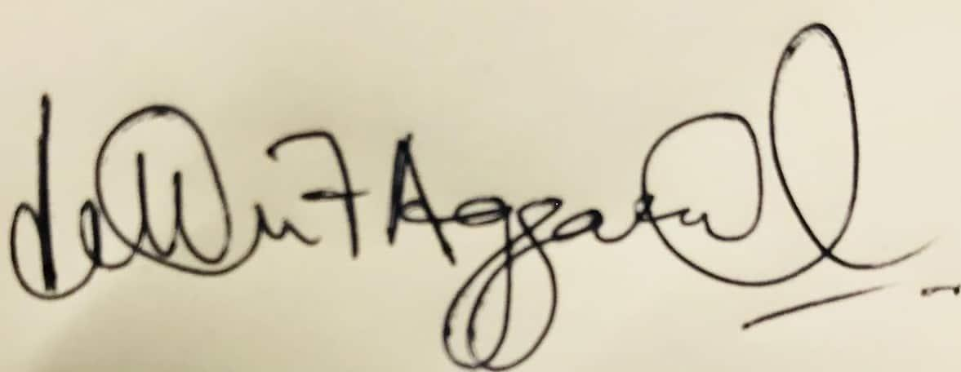 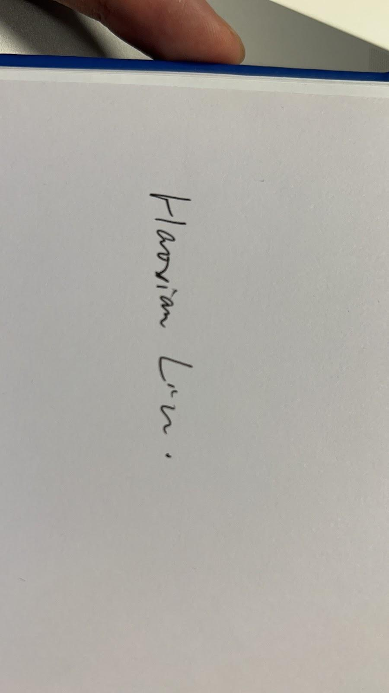

___________________ , _____________________ , ________________ , ______________________

**Date:** 16/02/2023

**Week Number:** 3

**Present:** Arnav Bhattacharya, Haoxian Liu, Kaize Shen, Pallavit Aggarwal, Chirag Saxena

**Agenda:**

Presentation of literature review findings by team members

Identification of relevant studies and methodologies

Refinement of research questions based on literature review

**Minutes:**

The team members presented their findings from the literature review and identified relevant studies and methodologies. They refined their research questions based on the literature review.

**Next Meeting on: 23/02/2023**

**Arnav Bhattacharya, Pallavit Aggarwal, Haoxian Liu, Kaize Shen**

  

___________________ , _____________________ , ________________ , ______________________

**Date:** 23/02/2023

**Week Number:** 4

**Present:** Arnav Bhattacharya, Haoxian Liu, Kaize Shen, Pallavit Aggarwal

**Agenda:**

Discussion of data sources, including official university websites and annual reports

Determination of the number of universities to include in the study

Development of a data collection plan and assignment of responsibilities

**Minutes:**

The team members discussed data sources, including official university websites and annual reports. They determined the number of universities to include in the study and developed a data collection plan. The team assigned responsibilities for data collection.

**Next Meeting on: 02/03/2023**

**Arnav Bhattacharya, Pallavit Aggarwal, Haoxian Liu, Kaize Shen**

  

___________________ , _____________________ , ________________ , ______________________

**Date:** 02/03/2023

**Week Number:** 5

**Present:** Arnav Bhattacharya, Haoxian Liu, Kaize Shen, Pallavit Aggarwal

**Agenda:**

Presentation of the completed mid-term paper, summarizing the project's progress, methodology, and preliminary results

Team discussion on the paper's structure, content, and clarity

**Minutes:**

The team members presented the completed mid-term paper, summarizing the project's progress, methodology, and preliminary results. They discussed the paper's structure, content, and clarity and made suggestions for revisions.

**Next Meeting on: 09/03/2023**

**Arnav Bhattacharya, Pallavit Aggarwal, Haoxian Liu, Kaize Shen**

  

___________________ , _____________________ , ________________ , ______________________

**Date:** 09/03/2023

**Week Number:** 6

**Present:** Arnav Bhattacharya, Haoxian Liu, Kaize Shen, Pallavit Aggarwal, Sarathkumar Thirukonda Ramkumar(Group 5), Vivek Bhadula (Group 6)

**Agenda:**

Update on data collection progress

Review of collected strategic plans and QS rankings

Assignment of tasks for revising the paper based on the feedback received

**Minutes:**

The team members provided an update on data collection progress and reviewed collected strategic plans and QS rankings. They assigned tasks for revising the paper based on feedback received. Thegroup discussed about various methods for topic modelling, LDA, NMF. We exchanged information regarding the datasets with our guest ambassadors. Also had a brief discussion regarding the viability of Spearman’s and Pearson’s coefficients in both of our cases.

**Next Meeting on: 16/03/2023**

**Arnav Bhattacharya, Pallavit Aggarwal, Haoxian Liu, Kaize Shen**

  

___________________ , _____________________ , ________________ , ______________________

**Date:** 16/03/2023

**Week Number:** 7

**Present:** Haoxian Liu, Kaize Shen, Pallavit Aggarwal, Tingzhou Wan(group 1) Arnav Bhattacharya (went to Group 5)

**Agenda:**

Presentation of data preprocessing steps, including text extraction, cleaning

Discussion of feature extraction techniques, such as TF-IDF, LSA, and LDA

**Minutes:**

The team members presented data preprocessing steps, including text extraction and cleaning. They discussed feature extraction techniques, such as TF-IDF, LSA, and LDA.

**Next Meeting on: 23/03/2023**

**Arnav Bhattacharya, Pallavit Aggarwal, Haoxian Liu, Kaize Shen**

  

___________________ , _____________________ , ________________ , ______________________

**Date:** 23/03/2023

**Week Number:** 8

**Present:** Arnav Bhattacharya, Haoxian Liu, Kaize Shen, Pallavit Aggarwal, Chirag Saxena

**Agenda:**

Explanation of agglomerative and divisive clustering approaches

Introduction to topic modeling methods, such as LSA and LDA

**Minutes:**

The team members explained and discussed the agglomerative and divisive clustering approaches and introduced topic modeling methods, such

**Next Meeting on: 30/03/2023**

**Arnav Bhattacharya, Pallavit Aggarwal, Haoxian Liu, Kaize Shen**

  

___________________ , _____________________ , ________________ , ______________________

**Date:** 30/03/2023

**Week Number:** 9

**Present:** Arnav Bhattacharya, Haoxian Liu, Kaize Shen, Pallavit Aggarwal

**Agenda:**

Discussion of approaches for analyzing the correlation between strategic plans and QS rankings

Development of a plan for comparing university clusters, topic distributions, and their rankings

Assignment of tasks for conducting the correlation analysis

**Minutes:**

The members discussed various approaches for analyzing the correlation between strategic plans and QS rankings. The discussion focused on identifying key performance indicators (KPIs) that would be useful in measuring the impact of strategic plans on QS rankings. The members also discussed the importance of identifying the causal relationship between strategic plans and QS rankings.

The members discussed the need for a comprehensive plan to compare university clusters, topic distributions, and their rankings. The plan will include a detailed methodology for analyzing the data and identifying the key factors that contribute to higher rankings. The members also discussed the importance of ensuring that the plan is transparent and replicable.

The members agreed to divide the tasks for conducting the correlation analysis among themselves. Kaize Shen will be responsible for collecting and analyzing the data on university clusters. Pallavit Aggarwal will be responsible for collecting and analyzing the data on topic distributions. Arnav Bhattacharya will be responsible for conducting the correlation analysis. The Chair will oversee the entire process and ensure that the tasks are completed on time.

**Next Meeting on: 06/04/2023**

**Arnav Bhattacharya, Pallavit Aggarwal, Haoxian Liu, Kaize Shen**

  

___________________ , _____________________ , ________________ , ______________________

**Date:** 06/04/2023

**Week Number:** 10

**Present:** Arnav Bhattacharya, Haoxian Liu, Kaize Shen, Pallavit Aggarwal

**Agenda:**

Presentation of correlation analysis findings

Discussion of observed patterns and potential implications

Identification of limitations and areas for further investigation

**Minutes:**

The team presented the findings of the correlation analysis, which showed a moderate positive correlation between the variables under study. The analysis revealed that the higher the level of education, the higher the income, and the lower the unemployment rate in the region. The team provided detailed charts and graphs to support their findings.

The team discussed the observed patterns and potential implications of the correlation analysis findings. They agreed that the results indicated the importance of education in the region's economic growth and development. They also discussed the potential implications for policy and decision-making, such as the need to invest in education and training programs to boost the region's economy.

The team identified several limitations of the study, such as the use of a limited set of variables and the lack of causality analysis. They also discussed areas for further investigation, such as the need to explore the relationship between education and other economic factors, such as productivity and innovation.

**Next Meeting on: 13/04/2023**

**Arnav Bhattacharya, Pallavit Aggarwal, Haoxian Liu, Kaize Shen**

  

___________________ , _____________________ , ________________ , ______________________

**Date:** 13/04/2023

**Week Number:** 11

**Present:** Arnav Bhattacharya, Haoxian Liu, Kaize Shen, Pallavit Aggarwal

**Agenda:**

1. Review of the draft project report, including methodology, results, and conclusions

2. Discussion of any necessary revisions or additions

3. Agreement on the final report structure and content

**Minutes:**  
 The draft project report was presented to the attendees, including the methodology, results, and conclusions. The attendees were given the opportunity to review the report and provide feedback.

The attendees discussed the draft report and suggested several revisions and additions, including the addition of further data analysis and clarification of certain parts of the methodology section. The attendees agreed to collaborate to address the revisions and additions.

After a thorough discussion and consideration of all the proposed revisions, the attendees reached an agreement on the final report structure and content. They confirmed that the report would include all the necessary components, and the report would be submitted by the agreed-upon deadline.

**Next Meeting on: 17/04/2023**

**Arnav Bhattacharya, Pallavit Aggarwal, Haoxian Liu, Kaize Shen**

  

___________________ , _____________________ , ________________ , ______________________

**Date:** 17/04/2023

**Week Number:** 12

**Present:** Arnav Bhattacharya, Haoxian Liu, Kaize Shen, Pallavit Aggarwal

**Agenda:**

1. Review and approval of the final report

2. Reflection on project successes and challenges

3. Acknowledgment of team members' contributions and project closure

**Minutes:**

The attendees then reflected on the project's successes and challenges. The team members shared their experiences and discussed what they learned during the project. They also discussed the challenges they faced, such as time constraints, resource constraints, and communication issues.

The attendees acknowledged and appreciated the contributions of all team members, recognizing the hard work, dedication, and collaboration that made the project successful. The team members expressed their gratitude towards each other.

The team then officially closed the project, noting the accomplishments and the lessons learned. The attendees agreed to stay in touch and continue collaborating in the future.

**Arnav Bhattacharya, Pallavit Aggarwal, Haoxian Liu, Kaize Shen**

  

___________________ , _____________________ , ________________ , ______________________